The Stuart Rossiter Trust announces a new book.

The British Free Franking System

Robert B. Galland FRPSL

With a contribution by John Colton

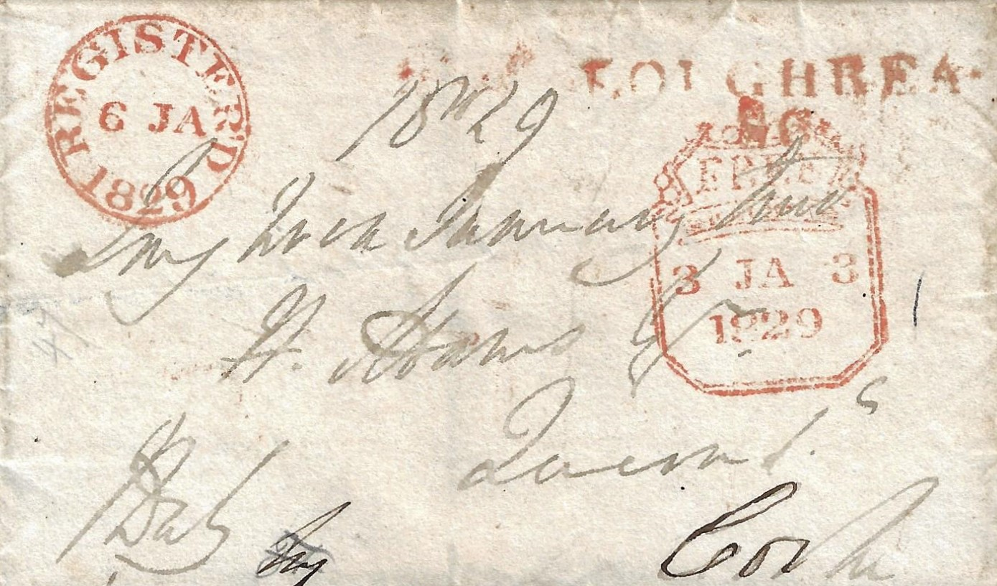
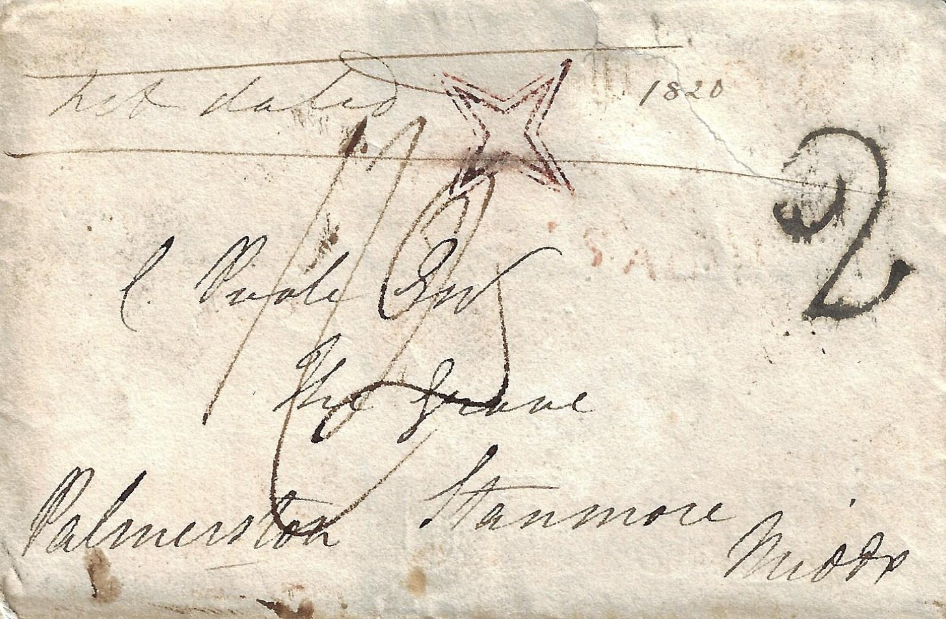

Hardbound 410 pages £35 (post free in UK) order from www.rossitertrust.com/

It is more than 30 years since the second edition of Lovegrove’s Herewith my Frank … and 15 years since the second edition of The British County Catalogue of Postal History (London) were published. In recent years there have been several new discoveries. An updated account of handstamps which showed that a letter was accepted for free franking is therefore timely.

How letters were accepted for free postage, privileged mail recognised and dealt with by Inspectors are detailed in this book. Also, why some mail passed free while other mail did not. After a general background of the franking system the ways in which senders indicated that a letter should go free are then described.
A new classification of handstamps associated with the franking system, based on the purpose of the stamp and office where it was applied, has been devised. Several handstamps not previously recorded in standard texts or journal articles are included. This volume complements Great Britain: Failed Free Handstamps of the Franking System by the same author published by the Rossiter Trust in 2014 available at £15. A free second supplement to that book can be found on the Rossiter Trust website. www.rossitertrust.com/

